**Exercise 5: Triggers**

**Scenario 1:** Automatically update the last modified date when a customer's record is updated.

**Question:** Write a trigger **UpdateCustomerLastModified** that updates the LastModified column of the Customers table to the current date whenever a customer's record is updated.

set serveroutput on;

CREATE OR REPLACE TRIGGER UpdateCustomerLastModified

BEFORE UPDATE ON Customers

FOR EACH ROW

BEGIN

:NEW.LastModified := SYSDATE;

END UpdateCustomerLastModified;

/

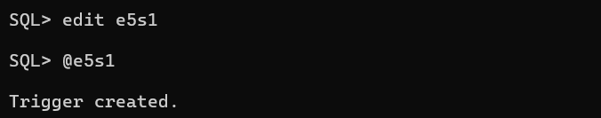

**Scenario 2:** Maintain an audit log for all transactions.

**Question:** Write a trigger **LogTransaction** that inserts a record into an AuditLog table whenever a transaction is inserted into the Transactions table.

CREATE TABLE AuditLog (LogID NUMBER PRIMARY KEY, TransactionID NUMBER, ActionDate DATE, ActionType VARCHAR2(50), Description VARCHAR2(255));

CREATE SEQUENCE AuditLog_seq START WITH 1 INCREMENT BY 1 NOCACHE NOCYCLE;

CREATE OR REPLACE TRIGGER LogTransaction

AFTER INSERT ON Transactions

FOR EACH ROW

BEGIN

INSERT INTO AuditLog (

LogID,

TransactionID,

ActionDate,

ActionType,

Description

)

VALUES (

AuditLog_seq.NEXTVAL, -- Auto-increment LogID using the sequence

:NEW.TransactionID,

SYSDATE,

'INSERT',

'Transaction added with amount ' || :NEW.Amount

);

END;

/

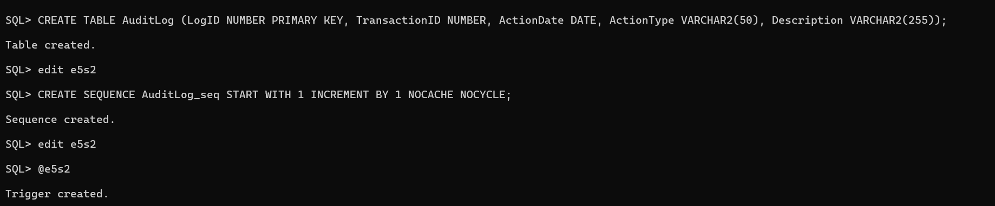

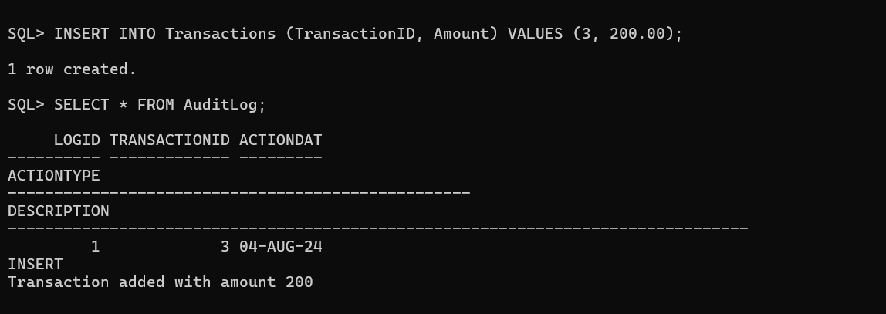

**Scenario 3:** Enforce business rules on deposits and withdrawals.

**Question:** Write a trigger **CheckTransactionRules** that ensures withdrawals do not exceed the balance and deposits are positive before inserting a record into the Transactions table.

set serveroutput on;

CREATE OR REPLACE TRIGGER CheckTransactionRules

BEFORE INSERT ON Transactions

FOR EACH ROW

DECLARE

v_balance NUMBER;

BEGIN

SELECT Balance INTO v_balance FROM Accounts WHERE AccountID = :NEW.AccountID;

IF :NEW.TransactionType = 'Withdrawal' AND :NEW.Amount > v_balance THEN

RAISE_APPLICATION_ERROR(-20004, 'Insufficient balance for withdrawal');

ELSIF :NEW.TransactionType = 'Deposit' AND :NEW.Amount <= 0 THEN

RAISE_APPLICATION_ERROR(-20005, 'Deposit amount must be positive');

END IF;

END CheckTransactionRules;

/





